Lettering Assignment
For this assignment, you will experiment with several different types of fonts. Lettering is a very important component to our artistic practice; it can be added to all proposals and any graphic design work you may do. Hand lettered signs are in high demand. Bring in that coin, one letter at time!
TO DO:
- For each of the seven fonts, recreate the alphabet. Then, write a phrase of your choice. This should take up a whole page in your sketchbook (for each font). Experiment with mediums.
- Research three more fonts/lettering styles on your own. Recreate the alphabet and write a phrase for each.

Checklist for Lettering Assignment:
Font | Alphabet and Phrase

1. LHF Hick Sticks

2. Simple Typography Alphabet

3. Futuracha
4. OllyMolly
5. LSTK Bembo
6. Sketch Block
7.Classic Cursive Writing
8.
9.
10.

- LHF Hick Sticks

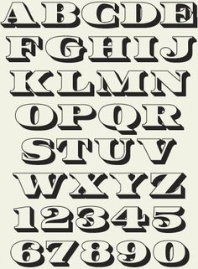
- Simple Typography Alphabet

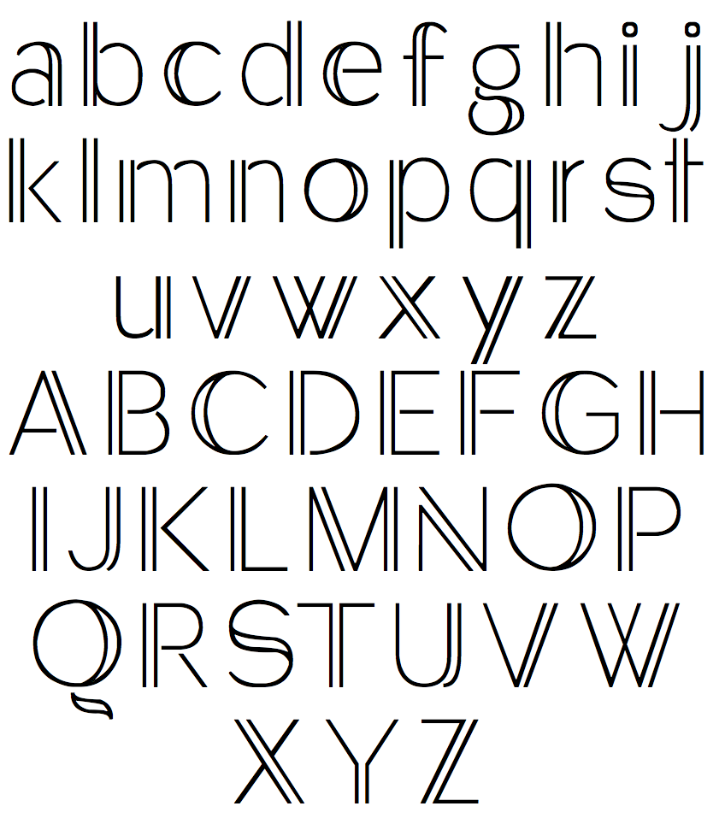

- Futuracha

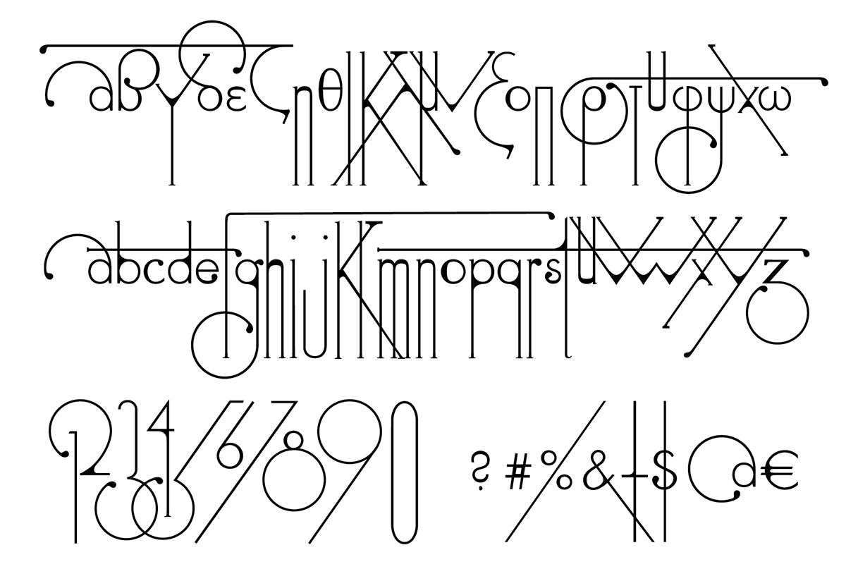
- OllyMolly
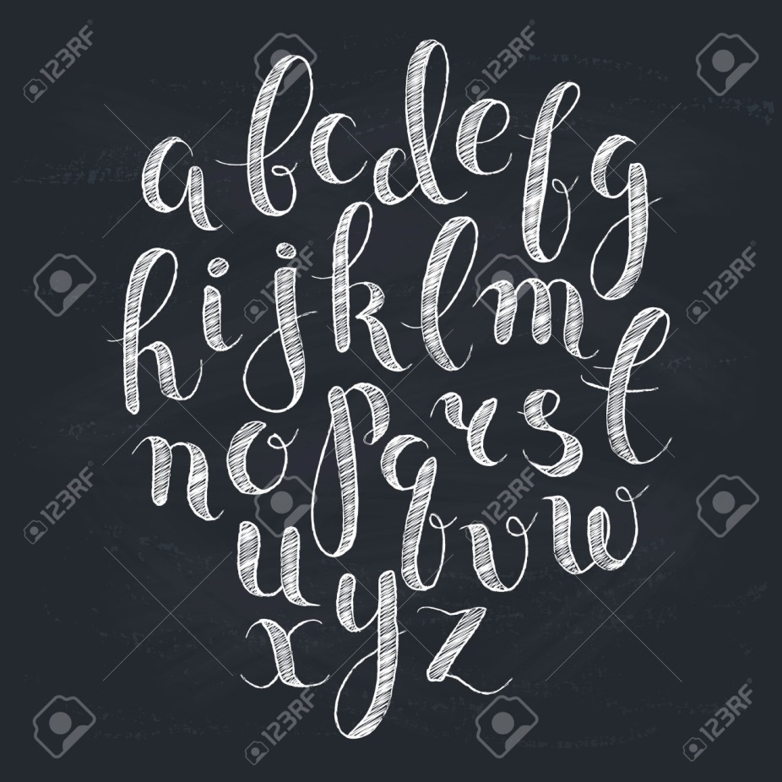
- Blue Water Alphabet
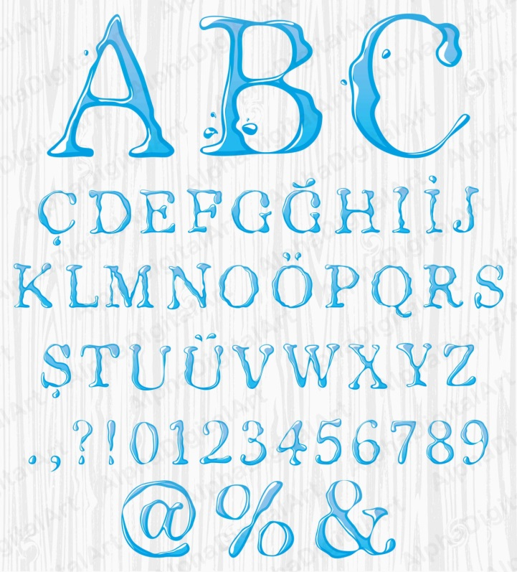

- Sketch Block
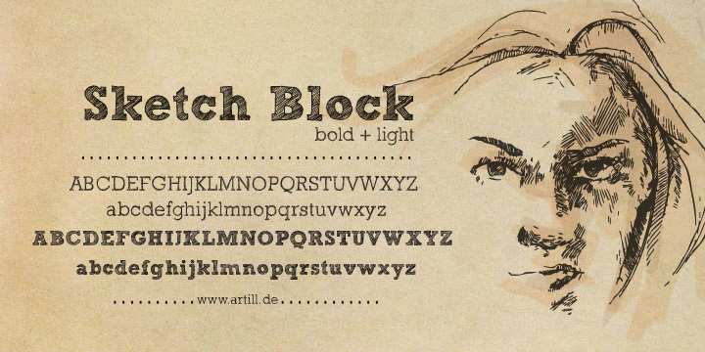
- Classic Cursive Writing
